PNER Membership Secretary
Job Description Created 11/14/18
LuAnn De Young appointed Jan. 1,2019
membership@pner.net

PNER Membership Secretary duties are primarily to get the renewals and/or new membership processed in the current database. There have been changes to the database over the past few years and this current one will be its initial year for go-live.
The busy times of year for this position will be both prior to convention, starting December and through to the first ride of the year. New memberships and/or renewals will trickle in through the early part of the year and typically are done by mid ride season. Any folks that may join towards the end of the year I would recommend they are given credit for the upcoming year.
These are the various membership types:
- Senior Membership – for persons age 16 or older as of January 1 of the current ride year.
- Junior Membership – for persons under the age of 16 as of January 1 of the current ride year.
- Family Membership – for all Senior and Junior members living at a single-family residence.
- Associate Member – persons who want to be members of PNER, but are not interested in a Senior Membership. Associate Members would not qualify for year-end awards, would not have a vote (per the by-laws) and could not run for office (as these positions could be voting positions). Associate Members would be eligible for any and all discounts offered by PNER to Senior Membership and would also receive the Newsletter.
Note: Please refer to the handbook for the Membership definitions, voting rights, award eligibility and revocation of membership. This will appear in the bylaws under Article II: Membership.
PNER and Oregon Horse Country have a reciprocal membership agreement. PNER trades a booth at the convention trade show for a booth at the Central Oregon Expo sponsored by OHC. PNER members also get the OHC discount at their other events. Brandi Ebner, Executive Director.
- After membership has been entered in the database, a PNER rider card will need to be created. For membership renewals and/or new members that renew/join from November through convention will receive their cards at convention. This can be done using Avery clear labels on the existing year’s PNER member card.
- For renewals/new memberships post-convention individual cards will need to be hand written (or labels if you bundle these memberships on a weekly or biweekly basis). All membership renewals post February 15th are required to pay the additional $5 to cover postage of handbook mailing.
- Handbooks are typically sent out several weeks before the first ride. A supply of handbooks will also be sent to the Membership Secretary. The membership card plus the handbook will need to be sent to renewals/new memberships post-convention that were not included in the bulk mailing that takes place with the Handbook person.
- Request additional postage from the Treasurer for PNER.
- Both the membership cards and Ride Manager cards are ordered from Documart
(phone 503-629-1893) in the late Fall of year prior to convention. Contact has been Tammy; however, any person at Documart can assist you. Identify you are with Pacific Northwest Endurance Rides, Inc. We have an account with this Documart, so they will deliver to your address and bill direct to the Treasurer of PNER.
- Ride Manager cards are typically ordered in a quantity of 500 for each distance; 25-mile, 50-mile, 75 mile and 100 miles. We have had these cards ordered in bright colors the past couple years, but a request has been made to do all reprints in buff colors. Documart has the template for these cards so a phone call is all that is required. Membership Secretary takes these cards to convention for the Ride Managers to pick up at the Ride Manager meeting that takes place, typically on the Friday of convention.
- Membership cards are also ordered (one box) in your color choice.
- A complete listing of memberships will need to be sent to the newsletter editor from convention. Monthly any renewals/ new memberships that have been received and entered in the database post-convention and send this list to the Newsletter Editor. This is done by using the export function on the Members tab of the PNER management side of the database.

Convention:
- Membership Secretary will work closely with the Convention Registration Coordinator, a relatively new role that has been loosely created to assist Membership Secretary. Convention Registration will start in December/January. This will include the membership renewals/new members at the same time as one document is created to capture both the convention registration plus the membership information and payment for both.
- A spreadsheet is developed that captures all components that members have registered for validation at the registration table.
- Membership Secretary purchases the name tags, wrist bands and clear labels for affixing membership information on cards (saves hand writing). Any ancillary items needed for convention registration table is also purchased. This can be done through the Treasurer to order on your behalf or purchasing then submitting an expense form (to be provided by the Treasurer).
- Registrants will receive their membership cards (typically placed in a small while envelope), along wit their arm bands for what they have registered for. These arm bands are of various colors to indicate whether full convention, speakers only, or dinner only.
- Typically, a recruiting takes place prior to convention to have folks assist with the actual registration desk at convention. This allows both the Convention Registration Coordinator and the Membership Secretary time to attend various lectures and/or visit.

Entering Membership:
Log into Management.pner.net
Select Members
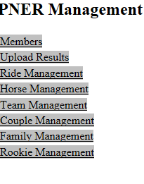
The following screen will appear:
Enter the name of the person that is renewing and click on Go.
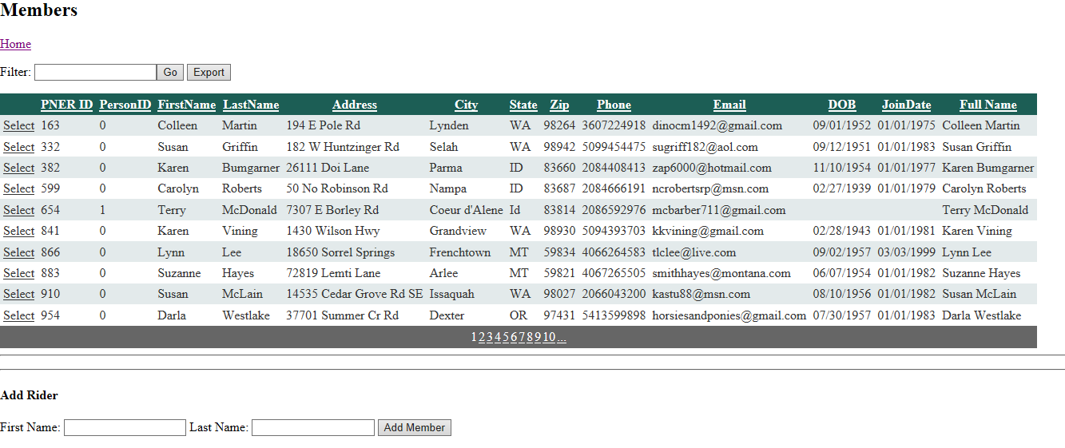

Click on Select if this is the member you plan on renewing:
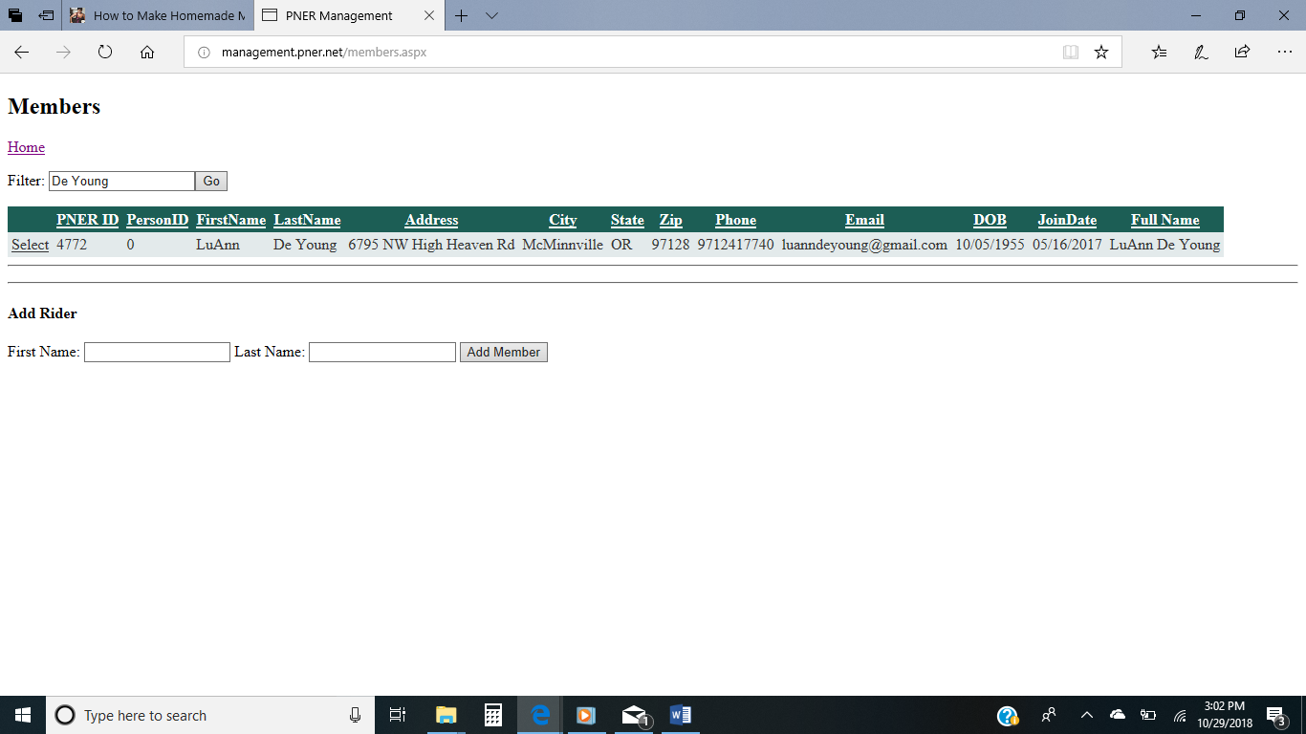

This is the screen where you can edit the renewing members information. If you make any changes then click on update to save these changes.
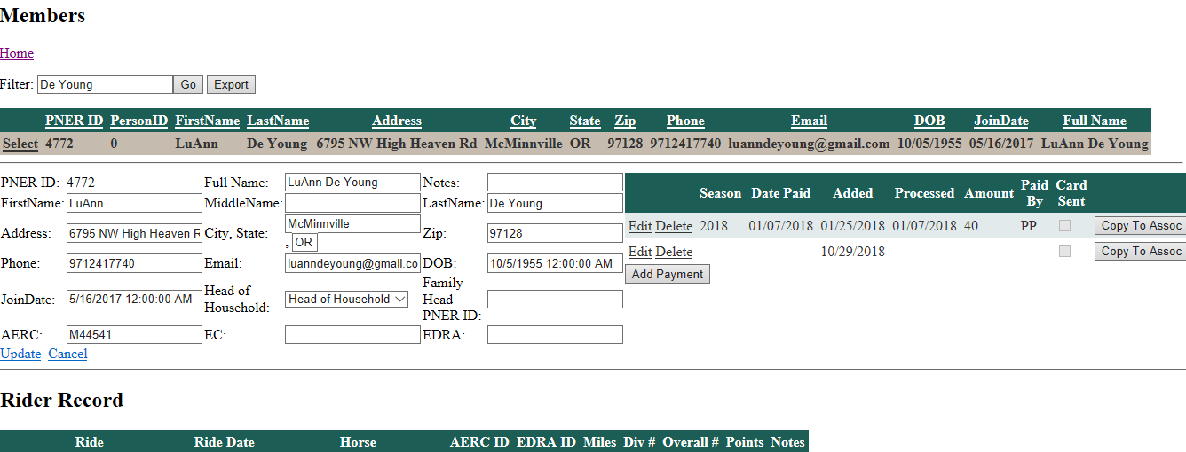
Note: Options are Head of Household… a single Senior would always be Head of Household, spouse and family would be Not HoH

Adding Payment for upcoming year’s membership:
Select Add Payment on the right side of the above form. The following screen will appear.
The day’s date is automatically entered. Select Edit to add the additional information. Click on card sent to indicate you have completed that renewal’s payment.
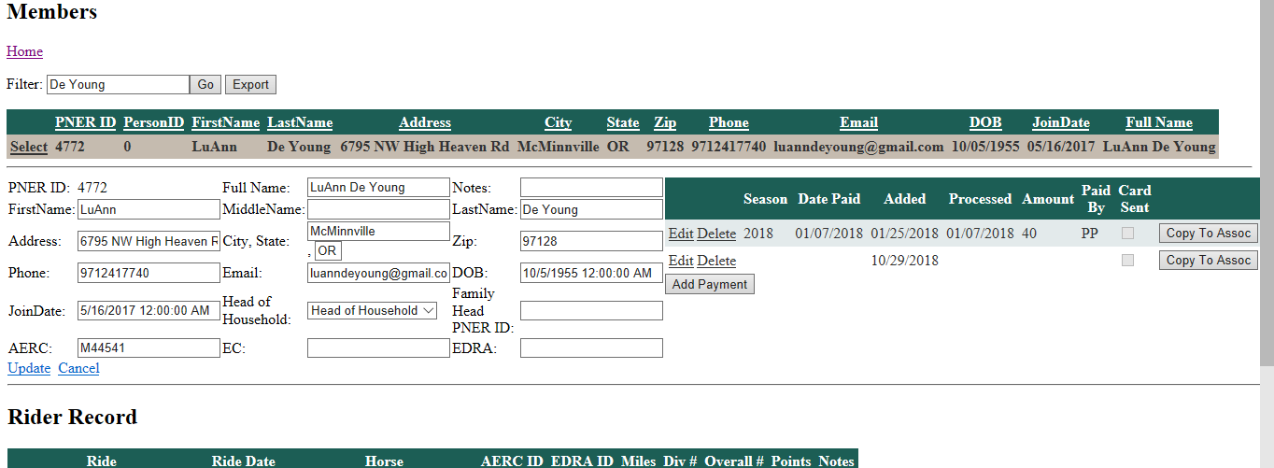

Couples Renewal Example:
In this example, Marlene is the Head of Household and Stace is not HOH… he is attached to Marlene’s PNER ID.
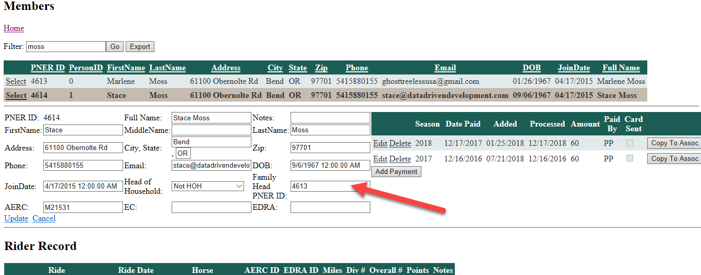

New Member:
Enter a name, if not found in the database the following screen will appear:
Enter the First Name Last Name and select Add Member.
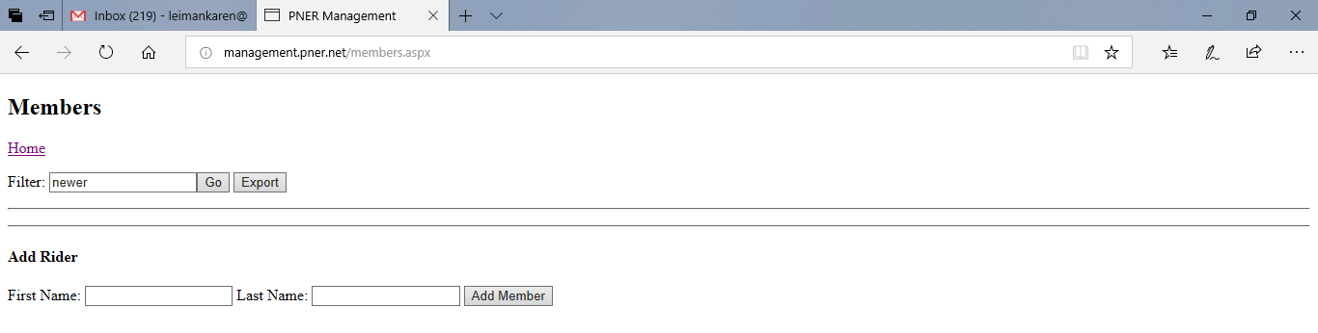
Select the new member
Note: Their PNER ID is now automatically generated.
.
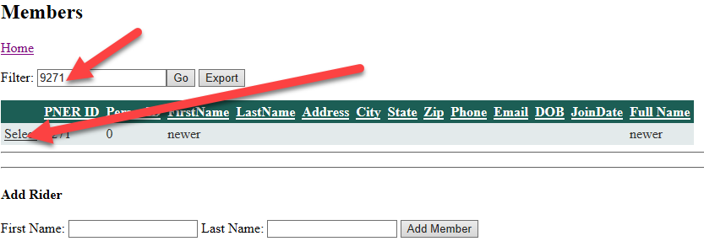

This is where you will enter all the information provided to you by the new member
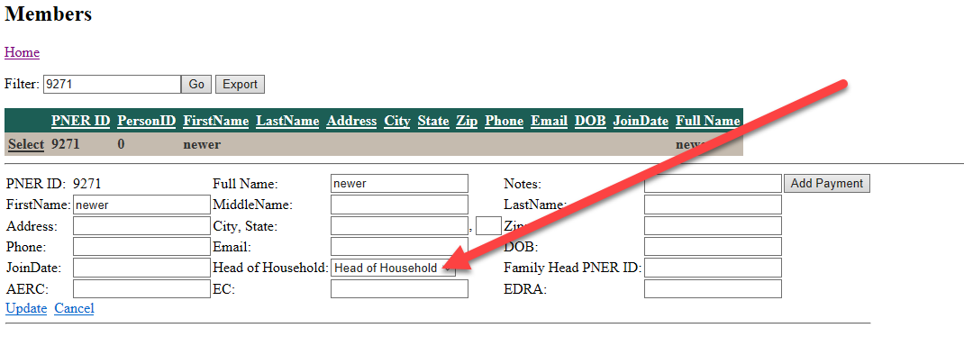Enter Head of Household and Not HOH for spouse or family members attached to this new member.
Note: Use the Head of Household PNER Id to link all spouse and/or family members. Refer to renewing members for couple and/or family information.
Once form is filled out (as complete as what you have for information) select Update.
Add Payment information.
Horse information will be automatically generated after the person’s first ride. Typically, you will not have their horse information.
Note: The first step for renewals/new memberships is to enter in the database then create the membership card and mail with the handbook. I have typically put the card in behind the front cover. Postage has typically been 5 stamps. This may change, so always check with the Post Office before assuming. If you are mailing more than one membership packet at a time then you can take to the Post Office and have them run the postage, make payment and request reimbursement from PNER Treasurer.
All out of pocket expenses, i.e. Labels, stamps, printer ink and envelopes are to be reimbursed by the Treasurer of PNER.
Payments made for memberships via PayPal will go directly to the PNER Treasurer. Payments via check will need to be photocopied (I would like up a few on them on one page) and stapled with the hard copy membership forms. An arrangement can be made between the Membership Secretary and the PNER Treasurer how to handle the deposit of said membership checks. This past year I deposited then sent a copy of the deposit form to the PNER Treasurer. Membership Secretary has access to the Pay Pal account, you can run periodic reports to confirm payments.

